Advanced SQL Exercises for Online Retail Store
Exercise 1: Ranking and Window Functions
Goal: Use ROW_NUMBER(), RANK(), DENSE_RANK(), OVER(), and PARTITION BY.
Scenario:
Find the top 3 most expensive products in each category using different ranking functions.
Steps:
1. Use ROW_NUMBER() to assign a unique rank within each category.
2. Use RANK() and DENSE_RANK() to compare how ties are handled.
3. Use PARTITION BY Category and ORDER BY Price DESC

SELECT *, ROW_NUMBER() OVER (PARTITION BY Category ORDER BY Price DESC) AS RowNum
FROM Products;

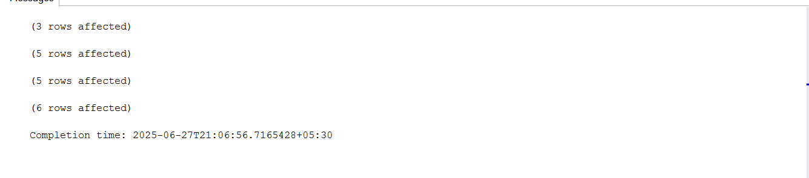

Exercise 2: Aggregation with GROUPING SETS, CUBE, and ROLLUP
Goal: Analyze sales data across multiple dimensions.
Scenario:
Generate a report showing total quantity sold by Region and Category using GROUPING SETS, ROLLUP, and CUBE.
Steps:
1. Join Orders, OrderDetails, Customers, and Products.
2. Use GROUPING SETS to get totals by Region, Category, and both.
3. Use ROLLUP to get subtotals and grand totals.
4. Use CUBE to get all combinations of Region and Category

SELECT Region, Category, SUM(Quantity) AS TotalQty
FROM Customers c
JOIN Orders o ON c.CustomerID = o.CustomerID
JOIN OrderDetails od ON o.OrderID = od.OrderID
JOIN Products p ON od.ProductID = p.ProductID
GROUP BY ROLLUP (Region, Category);

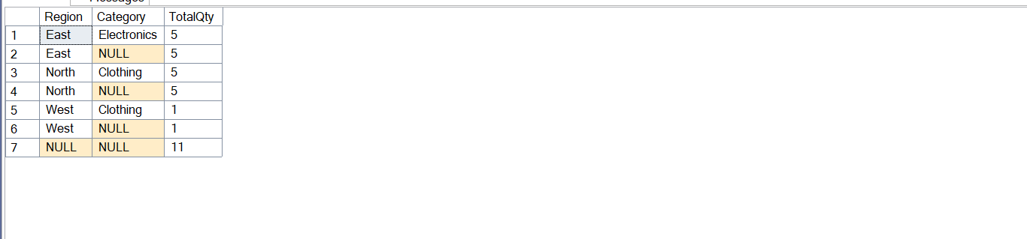

Exercise 3: CTEs and MERGE
Goal: Use WITH, CTEs, Recursive CTEs, and MERGE.
Scenario:
a) Create a recursive CTE to generate a calendar table.
b) Use a MERGE statement to update or insert product prices from a staging table.
Steps:
1. Create a recursive CTE to generate dates from '2025-01-01' to '2025-01-31'.
2. Create a StagingProducts table with updated prices.
3. Use MERGE to update existing products or insert new ones.

WITH Calendar AS (
SELECT CAST('2025-01-01' AS DATE) AS DateValue
UNION ALL
SELECT DATEADD(DAY, 1, DateValue)
FROM Calendar
WHERE DateValue < '2025-01-31'
)
SELECT * FROM Calendar
OPTION (MAXRECURSION 1000);

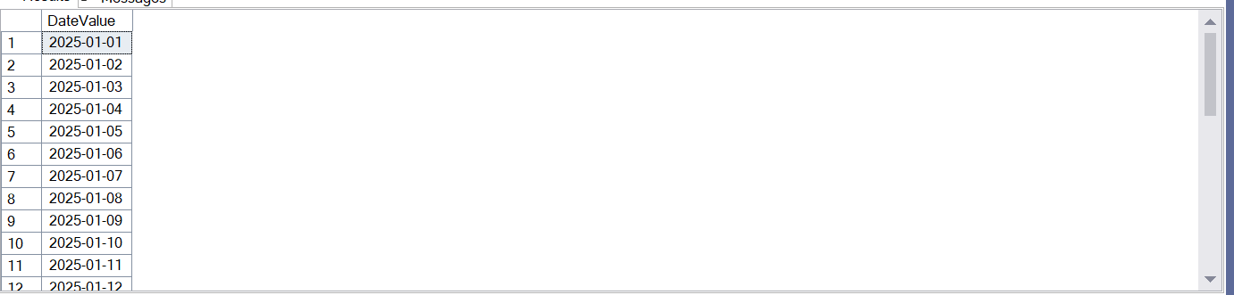

CREATE TABLE StagingProducts (
ProductID INT,
ProductName NVARCHAR(100),
Category NVARCHAR(50),
Price DECIMAL(10,2)
);

INSERT INTO StagingProducts VALUES
(101, 'Laptop', 'Electronics', 68000),
(106, 'Headphones', 'Electronics', 5000);

MERGE INTO Products AS target
USING StagingProducts AS source
ON target.ProductID = source.ProductID
WHEN MATCHED THEN
UPDATE SET target.Price = source.Price
WHEN NOT MATCHED THEN
INSERT (ProductID, ProductName, Category, Price)
VALUES (source.ProductID, source.ProductName, source.Category, source.Price);
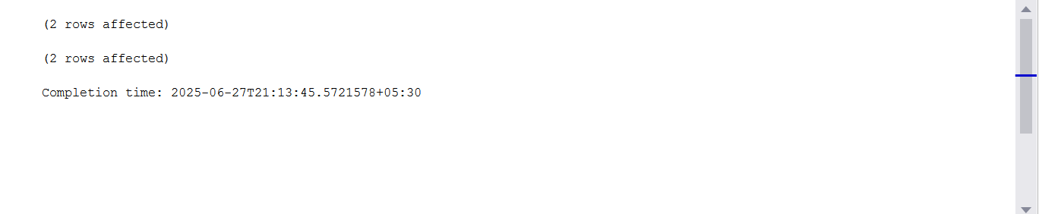

xercise 4: PIVOT and UNPIVOT
Goal: Transform data for reporting.
Scenario:
Show monthly sales quantity per product in a pivoted format, and then unpivot it back.
Steps:
1. Aggregate sales by Product and Month.
2. Use PIVOT to convert rows into columns (one column per month).
3. Use UNPIVOT to convert the pivoted data back into row format

-- Step 1: Aggregate total quantity sold by product and month
SELECT
p.ProductName,
FORMAT(o.OrderDate, 'yyyy-MM') AS SaleMonth,
SUM(od.Quantity) AS TotalQuantity
INTO #MonthlySales
FROM Orders o
JOIN OrderDetails od ON o.OrderID = od.OrderID
JOIN Products p ON od.ProductID = p.ProductID
GROUP BY p.ProductName, FORMAT(o.OrderDate, 'yyyy-MM');

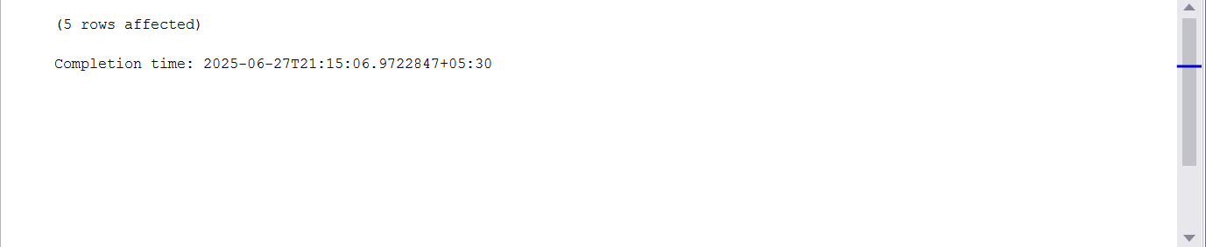
-- Step 2: Pivot to show one column per month
SELECT *
FROM (
SELECT ProductName, SaleMonth, TotalQuantity
FROM #MonthlySales
) AS SourceTable
PIVOT (
SUM(TotalQuantity)
FOR SaleMonth IN ([2025-01], [2025-02], [2025-03])
) AS PivotedTable;
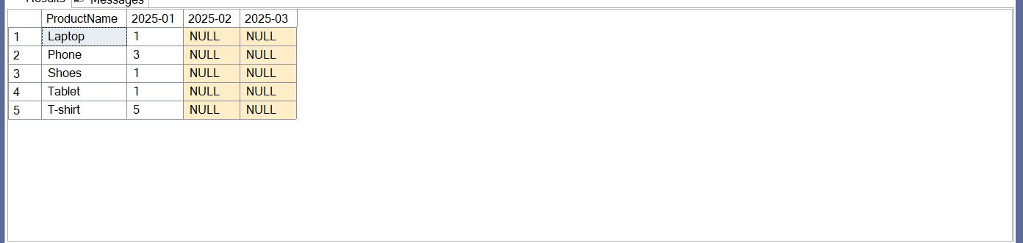

-- Step 3: Unpivot back to original format
SELECT ProductName, SaleMonth, Quantity
FROM (
SELECT ProductName, [2025-01], [2025-02], [2025-03]
FROM (
SELECT ProductName, SaleMonth, TotalQuantity
FROM #MonthlySales
) AS SourceTable
PIVOT (
SUM(TotalQuantity)
FOR SaleMonth IN ([2025-01], [2025-02], [2025-03])
) AS PivotedTable
) p
UNPIVOT (
Quantity FOR SaleMonth IN ([2025-01], [2025-02], [2025-03])
) AS UnpivotedTable;

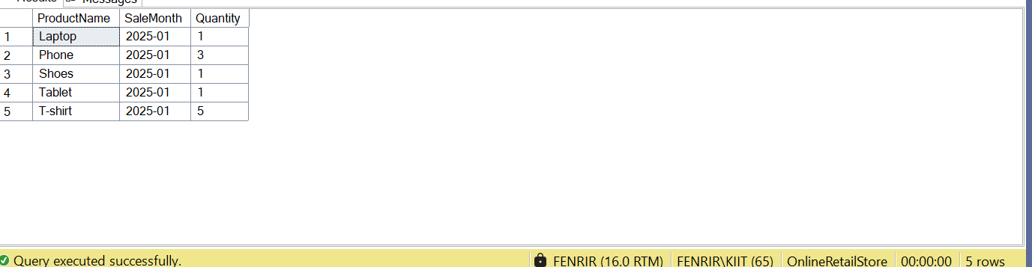

xercise 5: Using CTE to Simplify a Query
Goal: Use Common Table Expressions (CTEs) to simplify complex queries.
Scenario:
The business wants to find all customers who have placed more than 3 orders in total.
Steps:
1. Create a CTE that counts the number of orders placed by each customer.
2. Select only those customers who have placed more than 3 orders.
Sample Query:
WITH CustomerOrderCounts AS (
SELECT
o.CustomerID,
COUNT(o.OrderID) AS OrderCount
FROM Orders o
GROUP BY o.CustomerID
)
SELECT
c.CustomerID,
c.Name,
coc.OrderCount
FROM CustomerOrderCounts coc
JOIN Customers c ON c.CustomerID = coc.CustomerID
WHERE coc.OrderCount > 3;
-- Step 1: Define CTE to count orders per customer
WITH CustomerOrderCounts AS (
SELECT
o.CustomerID,
COUNT(o.OrderID) AS OrderCount
FROM Orders o
GROUP BY o.CustomerID
)

-- Step 2: Join with Customers table and filter
SELECT
c.CustomerID,
c.CustomerName,
coc.OrderCount
FROM CustomerOrderCounts coc
JOIN Customers c ON c.CustomerID = coc.CustomerID
WHERE coc.OrderCount > 3;
